|  |  |  |  |  |  |
| --- | --- | --- | --- | --- | --- |
| **S.no** | **Hidden Layers & Activation Used** | **Dense Units** | **Regularizations** | **Dropouts** | **Loss and Accuracy on Validation** |
| 1. | 2 & “relu” (From original code) | 16 | None | None | loss: 0.2774 - accuracy: 0.8880 |
| 2. | 1 & “relu” | 16 | None | None | loss: 0.2884 - accuracy: 0.8862 |
| 3. | 3 & “relu” | 16 | None | None | loss: 0.2763 - accuracy: 0.8916 |
| 4. | 1 & “relu” | 32 | None | None | loss: 0.2902 - accuracy: 0.8833 |
| 5. | 2 & “relu” | 32 | None | None | loss: 0.2793 - accuracy: 0.8892 |
| 6. | 3 & “relu” | 32 | None | None | loss: 0.2775 - accuracy: 0.8898 |
| 7. | 1 & “relu” | 64 | None | None | loss: 0.2909 - accuracy: 0.8833 |
| 8. | 2 & “relu” | 64 | None | None | loss: 0.2842 - accuracy: 0.8865 |
| 9. | 3 & “relu” | 64 | None | None | loss: 0.3108 - accuracy: 0.8803 |
| 10. | 2 & “tanh” | 64 | None | None | loss: 0.3181 - accuracy: 0.8776 |

|  |  |  |  |  |  |
| --- | --- | --- | --- | --- | --- |
| **S.no** | **Hidden Layers & Activation Used** | **Dense Units** | **Regularizations** | **Dropouts** | **Loss and Accuracy on Validation** |
| 11. | 2 & “relu” | 64 | None | None | loss: 0.0854 - Accuracy: 0.8858  (Mse loss function used. |
| 12. | 2 & “relu” | 16 | L2 = 0.001 | None | loss: 0.3245 - Accuracy: 0.8876 |
| 13. | 2 & “relu” | 64 | L2 = 0.001 | None | loss: 0.4183 - Accuracy: 0.8686 |
| 14. | 2 & “relu” | 32 | L1_L2(L1=0.001, L2=0.01) | None | loss: 0.6535 - accuracy: 0.8624 |
| 15. | 2 & “relu” | 64 | L1_L2(L1=0.001, L2=0.01) | None | loss: 0.7425 - accuracy: 0.8754 |
| 16. | 2 & “relu” | 16 | None | 0.5 | loss: 0.2708 - accuracy: 0.8923 |
| 17. | 2 & “relu” | 32 | None | 0.5 | loss: 0.2775 - accuracy: 0.8888 |
| 18. | 2 & “relu” | 16 | L2 = 0.001 | 0.5 | loss: 0.3283 - accuracy: 0.8869 |
| 19. | 2 & “relu” | 64 | L2 = 0.001 | 0.5 | loss: 0.3985 - accuracy: 0.8741 |

**Summary:**

* The above models were run along with the following parameters to build the model:

optimizer**=**'rmsprop', loss**=**'binary_crossentropy', metrics**=**['accuracy']).

* Use "mse" or mean squared error loss function except for model #11. Although the loss function "mse" shows a very small validation loss per epoch, it is not applicable for binary classification that aims to predict the correct label for each sample, while "mse" is used for continuous prediction in regression problems. variables.
* Using the "tanh" function instead of "relu" shows a sudden increase in validation loss up to 0.98 without affecting the validation accuracy.
* In the current data set, changing the hidden value from 2 to 1 and 3 does not make a significant difference, with a loss varying between 0.27 and an accuracy of 0.88.
* Changing the density units from 16 to 32 and 64 shows a slight increase in validation loss at each time step and no significant change in accuracy.
* The regularization concept helps control data overfitting by adding a penalty to the high weight function. In the current scenario, regulations of L2 = 0.001 have been applied, where the incremental cost is proportional to the square of the value of the weighting factors.

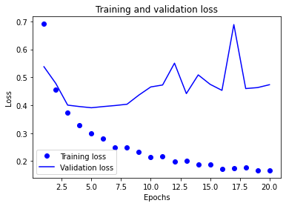

* The effect of L2 regulation is clearly visible with the validation loss peaking at 0.6887. But the validation accuracy is still constant at 0.88.
* 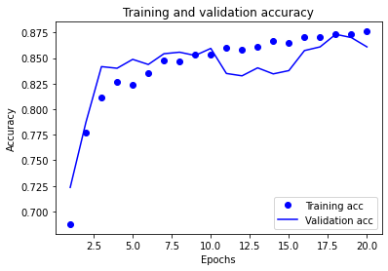The regulation concept can be applied with L1 and L2 to reduce overflow. The current regulation was set to L1_L2(L1=0.001, L2=0.01).

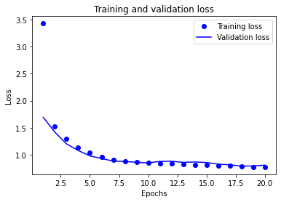

* The above comparison shows how the regularization model affects the validation loss and accuracy. The influence weight is high in both the training and validation set. Both training and validation sets have relative loss and accuracy.
* Chart

  Description automatically generatedDrop-out is another method of regularization to control the overfitting of data.Chart

  Description automatically generated
* From the above, drop-out is effective concerning overfitting. The validation accuracy shows an increase of 0.8923.
* Because previous models showed improvement by controlling for L2 and discontinuities, we used L2 and discontinuity together to test model improvement. Applying both regularizations shows no significant performance improvement, as the model accuracy is a constant 0.88.

**Conclusion:**

Comparing the model with different parameters, the regularization method using dropout showed an accuracy improvement of 0.8923 compared to the other models, and the loss of the validation set was 0.2708. As a hyperparameter, we can use the dropout method to tune the model to increase the accuracy of the model.